Java Assignment-1
Problem Statement 1 – Write a program in java to check if the two given words are anagrams or not.

Code –
import java.util.Scanner;
public class anagram {
public static void main(String[] args) {
Scanner sc = new Scanner(System.in);
char choice;
do {
System.out.print("Enter the 1st word to be checked: ");
String word = sc.nextLine();
System.out.print("Enter the 2nd word to be checked: ");
String word2 = sc.nextLine();
int length1 = word.length();
int length2 = word2.length();
boolean anagram = true;
if (length1 != length2) {
anagram = false;
} else {
for (int i = 0; i < length1; i++) {
int count1 = 0;
int count2 = 0;
for (int j = 0; j < length1; j++) {
if (word.charAt(i) == word.charAt(j)) {
count1++;
}
if (word.charAt(i) == word2.charAt(j)) {
count2++;
}
}
if (count1 != count2) {
anagram = false;
break;
}
}
}
if (anagram) {
System.out.println("It is an Anagram.");
} else {
System.out.println("Not an Anagram.");
}
System.out.print("Do you wish to continue? (y/n): ");
choice = sc.nextLine().charAt(0);
} while (choice == 'y' || choice == 'Y');
System.out.println("Program Ended!");
sc.close();
}
}
Output
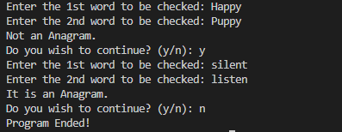

Problem Statement 2 – Write a program in java to analyze a student's name and perform operations on it.

Code -
import java.util.Scanner;
public class name {
public static void main(String[] args) {
Scanner sc = new Scanner(System.in);
char choice;
do {
System.out.print("Enter your full name: ");
String name = sc.nextLine();
String name1 = name.trim();
int len = name1.length();
System.out.println("Number of characters: " + len);
int preSpace = name1.indexOf(" ");
int sufSpace = name1.lastIndexOf(" ");
String firstName = name1.substring(0, preSpace);
String lastName = name1.substring(sufSpace, len);
System.out.println("First name: " + firstName);
System.out.println("Last name: " + lastName);
String low = name1.toLowerCase();
String up = name1.toUpperCase();
System.out.println("Name in Lower case: " + low);
System.out.println("Name in Upper case: " + up);
System.out.print("Enter character to be searched for: ");
char search = sc.nextLine().charAt(0);
boolean found = false;
for (int j = 0; j < len; j++) {
if (name1.charAt(j) == search) {
System.out.println("Character found at index: " + j);
found = true;
}
}
if (found == false) {
System.out.println("Character not found!");
}
String[] words = name1.split(" ");
System.out.print("Reversed Name: ");
for (int i = words.length - 1; i >= 0; i--) {
System.out.print(words[i] + " ");
}
System.out.println();
System.out.println("Do you wish to continue? (y/n)");
choice = sc.nextLine().charAt(0);
} while (choice == 'y' || choice == 'Y');
System.out.println("Program Ended!");
sc.close();
}
}

Output –
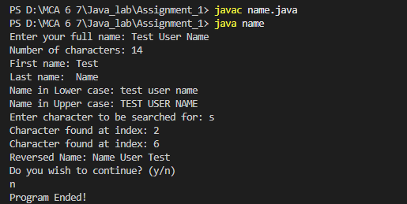
Problem Statement 3 – Write a program in java to analyze user’s entered password and analyze its strength.

Code -
import java.util.Scanner;
public class password {
public static void main(String args[]) {
Scanner sc = new Scanner(System.in);
char choice;
do {
System.out.print("Enter your password:");
String str = sc.nextLine();
int length = str.length();
int score = 0;
boolean special = false;
boolean digit = false;
boolean lower = false;
boolean upper = false;
for (int i = 0; i < str.length(); i++) {
char ch = str.charAt(i);
if (ch >= '0' && ch <= '9') {
digit = true;
}
if (ch >= 'A' && ch <= 'Z') {
upper = true;
}
if (ch >= 'a' && ch <= 'z') {
lower = true;
}
if (!(ch >= 'A' && ch <= 'Z' ||
ch >= 'a' && ch <= 'z' ||
ch >= '0' && ch <= '9')) {
special = true;
}
}
if (special)
score++;
if (digit)
score++;
if (lower)
score++;
if (upper)
score++;
if (length >= 8)
score++;
if (score == 5) {
System.out.println("Password is strong.");
} else if (score >= 3) {
System.out.println("Password is medium.");
} else {
System.out.println("Password is weak.");
}
System.out.print("\n Do you wish to continue?(y/n):");
choice = sc.next().charAt(0);
sc.nextLine();
} while (choice == 'y' || choice == 'Y');
System.out.println("Program ended");
sc.close();
}
}

Output –
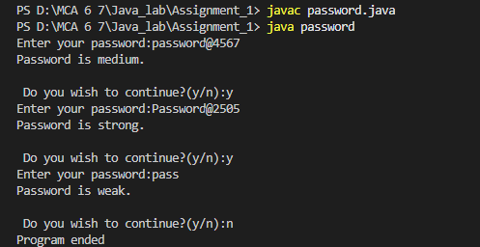

Problem Statement 4 – Write a program in java to analyze words or strings entered by user to count the number of occurrences of certain words or measure frequencies of words appearing in sentence.

Code –
import java.util.Scanner;

public class frequency {
@SuppressWarnings("ConvertToTryWithResources")
public static void main(String args[]) {
Scanner sc = new Scanner(System.in);
char choice;
do {
System.out.print("Enter your sentence to be analyzed: ");
String str = sc.nextLine();
String[] words = str.trim().split(" ");
int count = words.length;
int maxcount = 0;
String mostFrequent = "";
System.out.println("Word Count: " + count);
for (int i = 0; i < words.length; i++) {
boolean checked = false;
for (int j = 0; j < i; j++) {
if (words[i].equals(words[j])) {
checked = true;
}
}
if (!checked) {
int counter = 0;
for (int k = 0; k < words.length; k++) {
if (words[i].equals(words[k])) {
counter++;
}
}
if (counter > maxcount) {
maxcount = counter;
mostFrequent = words[i];
}
System.out.println(words[i] + " occurs " + counter + " times");
}
}
System.out.println("Most frequent word: " + mostFrequent + " occurs " + maxcount + " times");
System.out.print("\n Do you wish to continue?(y/n):");
choice = sc.next().charAt(0);
sc.nextLine();
} while (choice == 'y' || choice == 'Y');
System.out.println("Program ended");
sc.close();
}
}

Output –
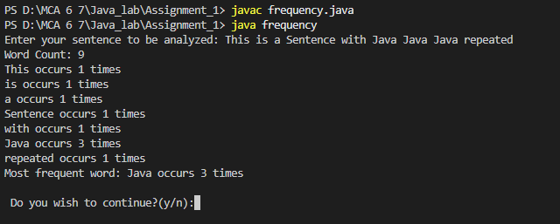

Problem Statement 5 – Write a program in java to compress strings entered by user for eg –
Input – aaaaaabbbbbbcccd
Output – a6b6c3d1

Code –
package Java_lab.Assignment_1;

import java.util.Scanner;

public class compress {
public static void main(String[] args) {

Scanner sc = new Scanner(System.in);
char choice;

do {
System.out.print("Enter string to be compressed: ");
String str = sc.nextLine();
String compress = "";
int count = 1;
int length = str.length();
for (int i = 1; i < length; i++) {
if (str.charAt(i) == str.charAt(i - 1)) {
count++;
} else {
compress = compress + str.charAt(i - 1) + count;
count = 1;
}
}
compress = compress + str.charAt(length - 1) + count;
System.out.println("Compressed String: " + compress);
System.out.println("Do you wish to continue? (y/n)");
choice = sc.nextLine().charAt(0);
} while (choice == 'y' || choice == 'Y');
System.out.println("Program Ended!");
sc.close();
}
}

Output –
